|  |
| --- |
| **logo_iff** |
| RUNBOOK  Identify SSL TLS Version |
| December 7, 2018 |

**logo_iff**

© 2016 - 2018 IFF. All rights reserved.

No part of this technical document may be reproduced, stored in a retrieval system, or transmitted, in any form or by any means, mechanical, electronic, photocopying, recording, or otherwise, without prior written permission from IFF. The IFF logo is a trademark of IFF, registered in the U.S. and other countries.

|  |  |
| --- | --- |
| IFF Global Headquarters  521 West 57th Street  New York, NY 10019  United States  212-765-5500  [www.iff.com](http://www.iff.com) | IFF Infrastructure Services  1515 State Highway #36  Union Beach, New Jersey 07735  732-264-4500 |

|  |  |
| --- | --- |
| **Document Contributors and Approvers** | |
| The individuals listed below were involved in the creation, review and approval of this document. This section is for reference only. | |
| Name | Role |
| MAHESH G | Document Author |
| SENTHIL/GEORGE | Reviewer and Approver |
|  |  |
|  |  |
|  |  |
|  |  |
|  |  |

|  |  |  |  |
| --- | --- | --- | --- |
| **Version Control** | | | |
| Details regarding the version control of this document can be found below. | | | |
| Date Created | Effective Date | Expiration / Review Date | Modified Date |
| Dec 02, 2018 | DEC 02, 2018 |  | December 7, 2018 |

|  |  |  |  |  |  |
| --- | --- | --- | --- | --- | --- |
| Modified By: | MAHESHUMANATH G | Version: | 1.0 | Revision: |  |

Table of Contents

[Runbook for ZSCALER Botnet & Phsihing REDIRECTION 4](#_Toc529795005)

[Purpose 4](#_Toc529795006)

[Identify SSL & TLS Versions 5](#_Toc529795007)

[Identify Weak Cipher suites 11](#_Toc529795008)

# Runbook for SSL & TLS Version identify

## Purpose

The purpose of this runbook is to aid in identify Unsecure SSL & TLS and its Cipher Suites.

1. Please go URL >>> https://www.ssllabs.com/ssltest/

Type URLs of the websites to identify SSL & TLS Versions.

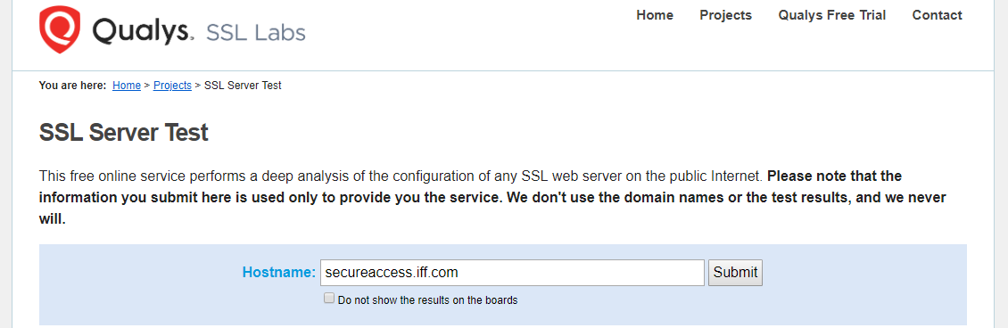

1. Click on submit button to run reports

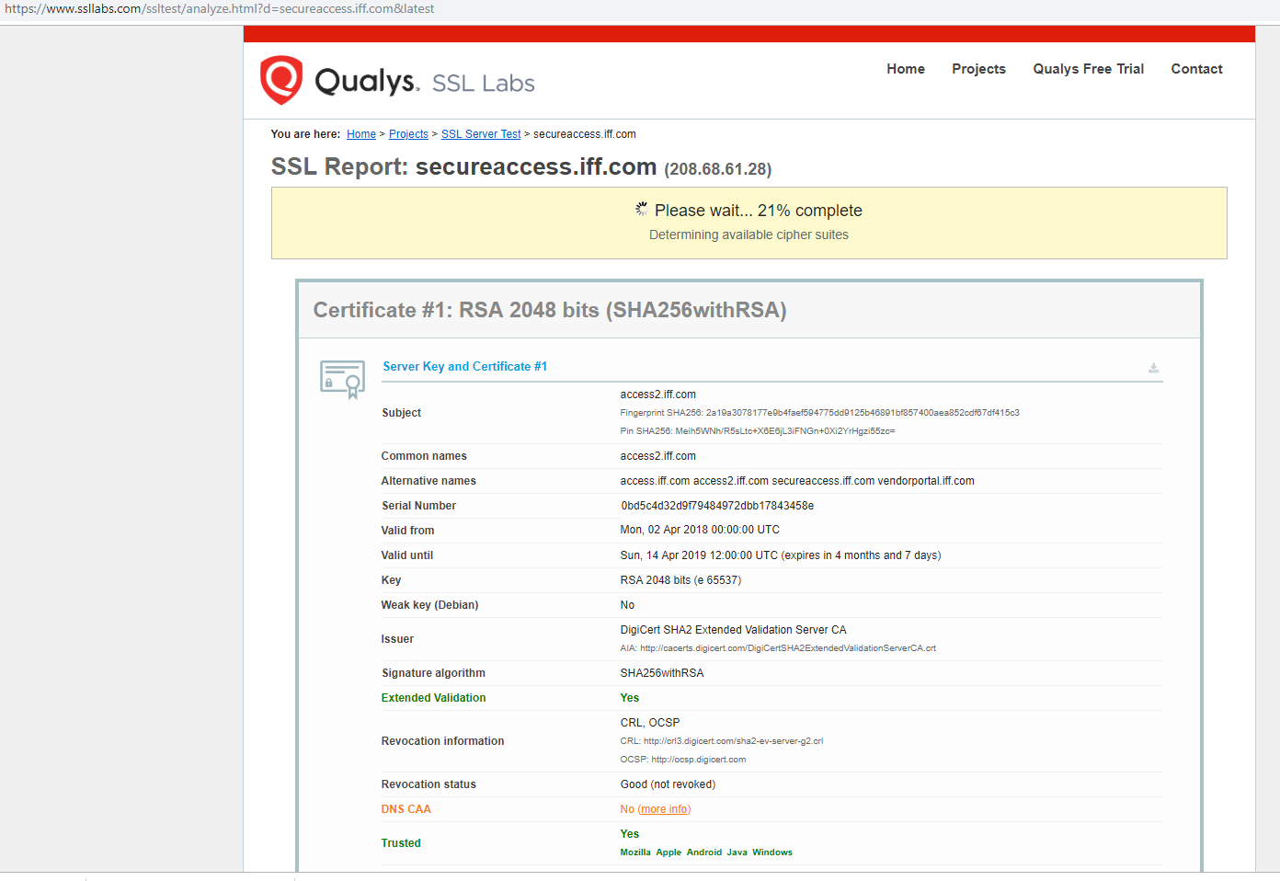

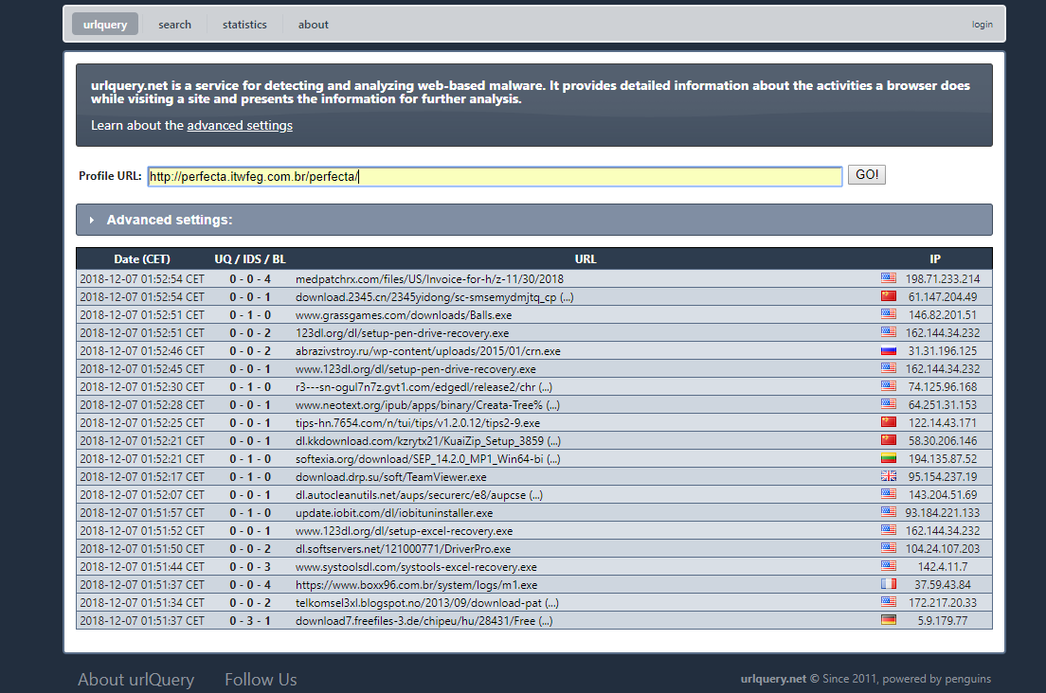

## URL REDIRECTIONS & HTTP TRANSCATIONS

3.After Click Go URL query will start to identify URLs domains & Sub domains and all http redirections.

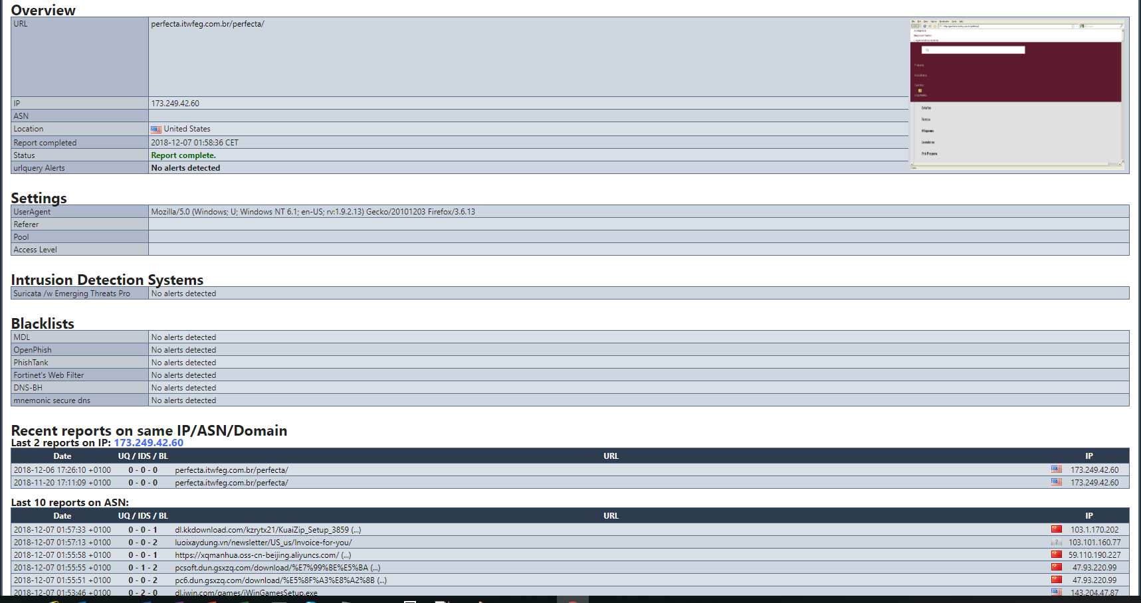

If its Falls on the Phishing Category it will show here

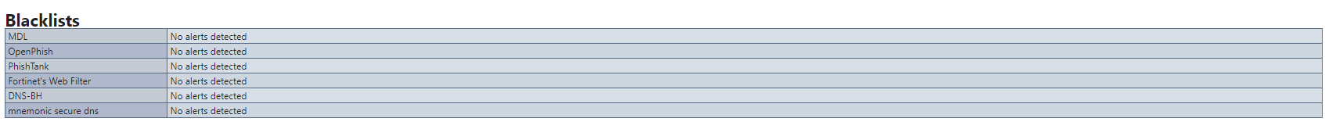

Below Figure will show Other sub domains which related to this & Black list Count

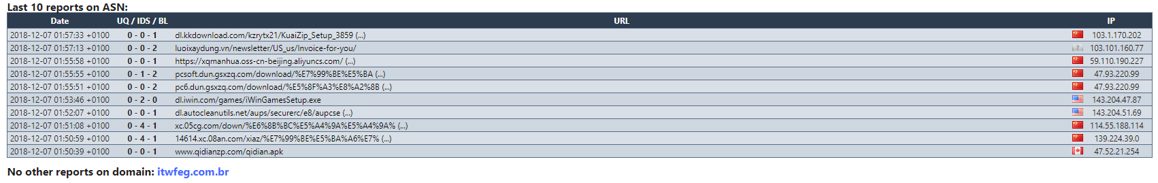

Purpose documents to identify URL Redirection Safely without impacting Production Environment.

Total Http transactions will able to see here

